2020 Resource Fair & Annual Meeting Registration Form
RESOURCE FAIR | COST
Non-Profit Vendor Table  (Includes 6ft table, space for two representatives, and two lunches to Annual Meeting) | $150
Vendor Table  (Includes 6ft table, space for two representatives, and two lunches to Annual Meeting) | $200
TOTAL = | $

Name of Organization:
Contact Person(s):
Email:
Phone #:
Resource Fair
Charles H. Hill
Community Center

9:00-11:30am and
1:30pm-4:00pm
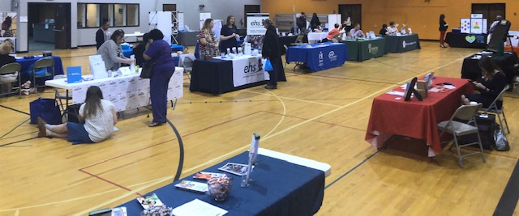

Annual Meeting
Vinton War Memorial Ballroom

11:30am-1:30pm

Keynote Speaker:
Lauren Sisler, Sportscaster for ESPN, SEC Network, and AL.com

Vin

ANNUAL MEETING LUNCHEON w/ KEYNOTE SPEAKER | COST | Quantity
Table for 10 | $180
Per person | $20
Per person with limited income | $1
NAMI-RV members** | Free
Name(s):
Email:
NAMI-RV Member? Yes or No | TOTAL = |  | $

www.namiroanokevalley.org Questions? Email us @
OR namiroanokevalley@gmail.com
NAMI-Roanoke Valley
P.O. Box 20864 REGISTRATION DEADLINE:
Roanoke, VA 24018 Monday April 13, 2020

*NAMI-RV Membership must be current by April 15, 2020.
**Space is limited for the Annual Meeting Luncheon**

